DAY 1 CODING CHALLENGE READ ME FILE

📊 Data Analyst Coding Challenge – Day 1
1. Project Overview
This project analyzes sales data for a retail company to evaluate regional performance, product category performance, and top-performing products.
The goal is to transform raw sales data into meaningful business insights using data cleaning, calculations, pivot tables, and charts.

Dataset Columns
Column | Description
Order_ID | Unique ID for each order
Order_Date | Date of purchase
Region | Sales region (North, South, East, West)
Product | Product name
Category | Product category
Quantity | Number of units sold
Unit_Price | Price per unit

Output Screenshots
Include screenshots of:
1️⃣ Raw dataset
2️⃣ Revenue calculation column
3️⃣ Pivot table – Revenue by Region
4️⃣ Pivot table – Revenue by Category
5️⃣ Top 5 Products table
6️⃣ Charts created

⚠️ Challenges Faced
1. Revenue Calculation
Ensuring correct multiplication between Quantity and Unit Price across all rows.
2. Pivot Table Sorting
Sorting products correctly to identify the Top 5 performers.
3. Visualization Choice
Selecting appropriate charts to clearly represent business insights.

💡 Key Business Insights
✔ West region performs best in terms of revenue.
✔ Electronics category drives most sales.
✔ Desk Chairs are the most profitable product.
✔ Accessories like mouse and keyboard generate strong revenue.
✔ North region could benefit from improved sales strategies.

🧰 Tools Used
- Microsoft Excel
- Pivot Tables
- Excel Formulas
- Data Visualization Charts

📌 Conclusion
This analysis demonstrates how raw sales data can be transformed into meaningful insights using basic Excel analytics techniques.
The results help the company:
- Understand regional sales performance
- Identify high-performing products
- Focus on profitable categories

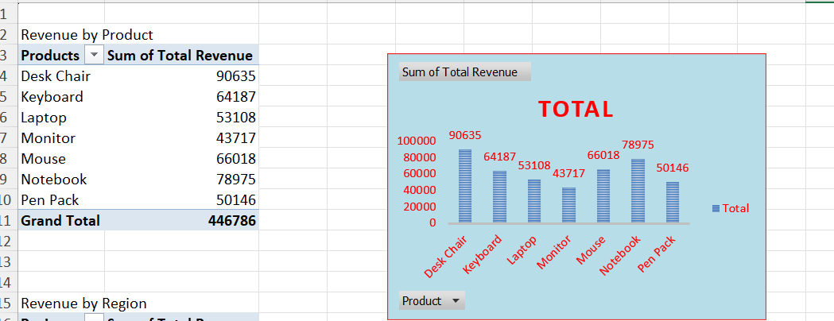

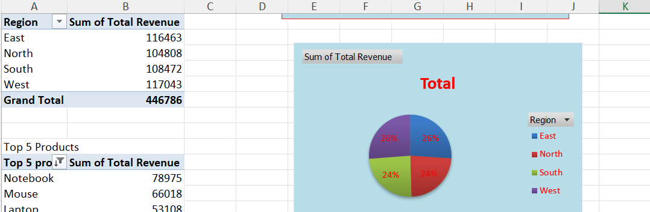

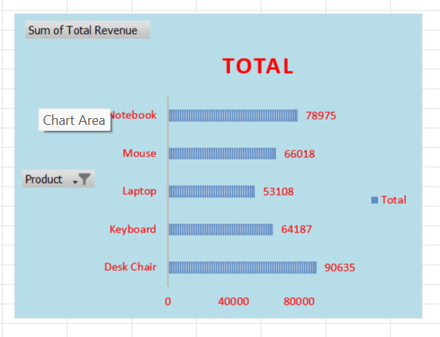

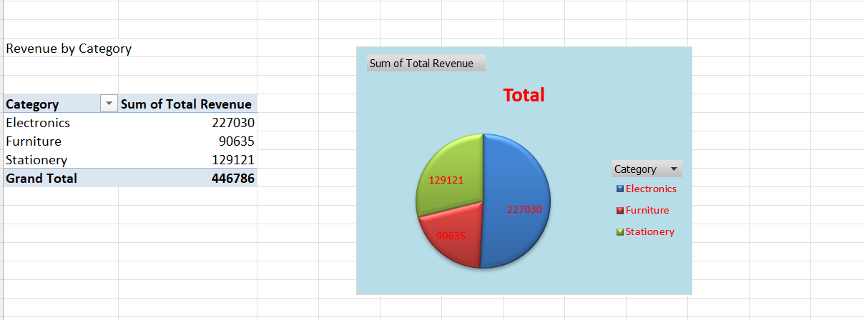

THANK YOU

